Name: Ateh Precious
Track: Computer Networking and Cyber security
REFLECTED CROSS-SITE SCRIPTING (XSS) VULNERABILITY
- Introduction
Reflected Cross-Site Scripting (XSS) is a web application vulnerability that occurs when user-supplied input is immediately returned in a web page without proper validation or output encoding. An attacker can create a malicious URL or input that executes JavaScript in the victim’s browser.
- Objective
The objective of this practical was to identify and demonstrate a reflected XSS vulnerability in a deliberately vulnerable web application and understand how improper handling of user input can allow JavaScript execution.
- Tools Used
- Kali Linux
- DVWA (Damn Vulnerable Web Application)
- Web browser
- Burp Suite (for observing HTTP requests)
- Procedure
- Opened DVWA in the web browser.
- Navigated to the Reflected XSS page.
- Entered a test input in the vulnerable input field.
- Submitted the input.
- Observed that the input was reflected in the page.
- Used Burp Suite to observe the HTTP request
- Proof of Vulnerability
The appearance of the alert box after submitting the payload demonstrated that the application did not properly encode or sanitize the supplied input before displaying it.
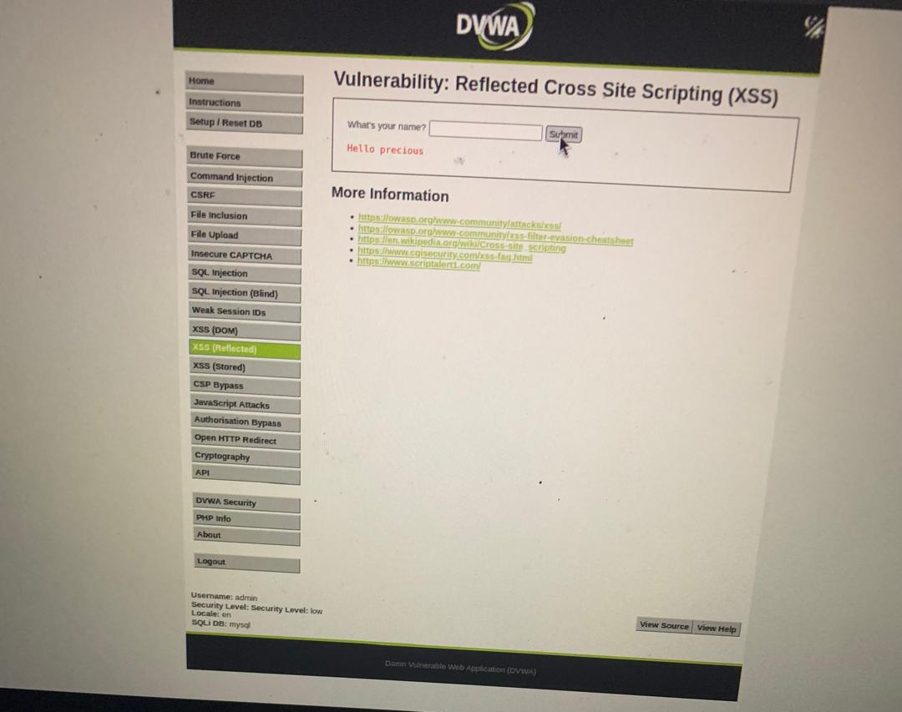
For example:
<script>alert('Reflected XSS Test')</script>
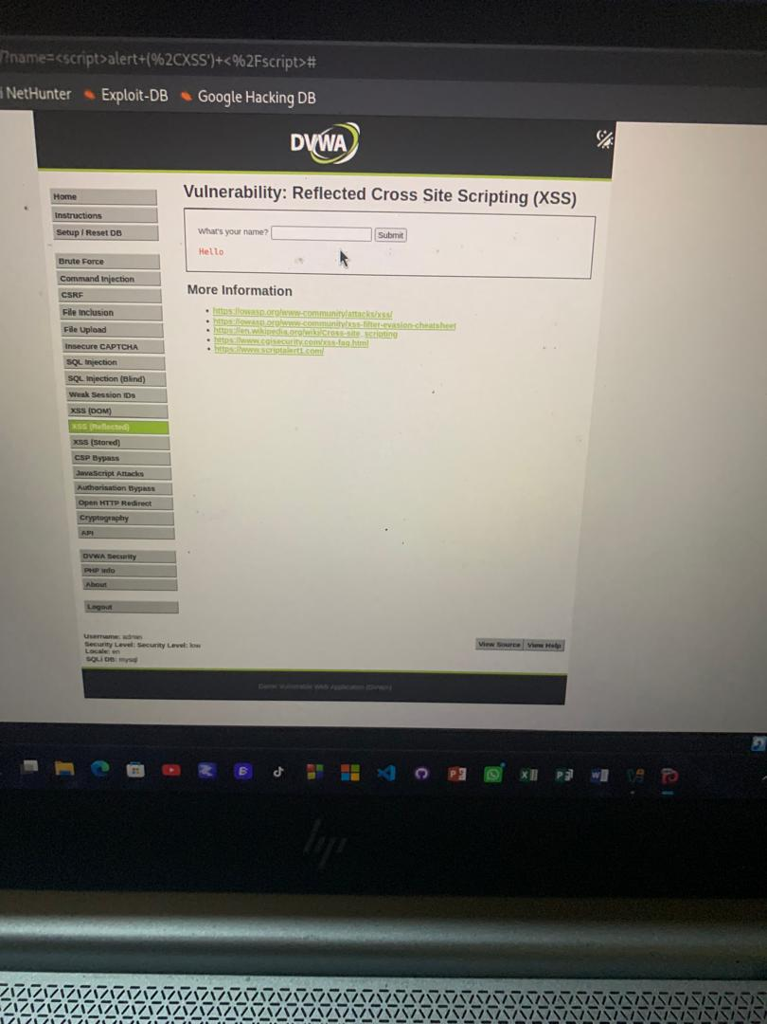
This was used only as a harmless proof-of-concept and did not collect real credentials or session information.
- Phishing and Session Hijacking Risk
An attacker could place a malicious XSS payload inside a URL and attempt to trick a victim into opening the link through phishing. If the vulnerable application processes the input without proper protection, JavaScript could execute in the victim’s browser under the application’s security context.
In a real attack, this could potentially be abused to perform unauthorized actions or attempt to access sensitive browser data. The practical demonstration therefore used only an alert instead of collecting real session cookies or credentials.
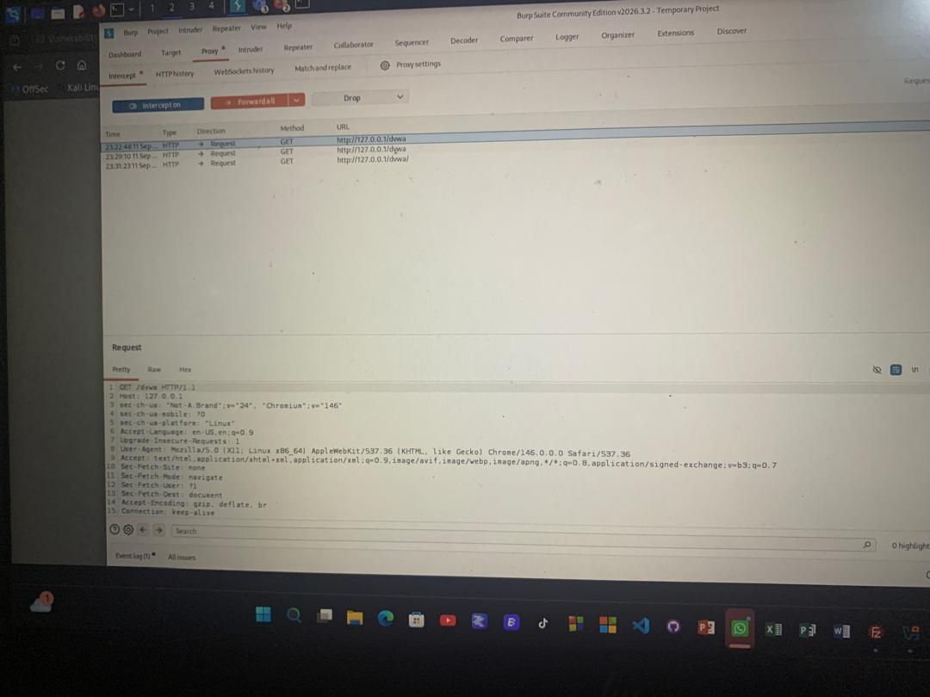
- Root Cause
The main cause of the vulnerability is lack of proper output encoding and input handling. The application takes user input and places it into the HTML response without treating it safely as data.
- Effect of Context on Payload Construction
The correct protection depends on where user input is inserted:
- HTML context: Special characters such as < and > should be HTML-encoded.
- HTML attribute context: Quotes and other attribute-sensitive characters must be properly encoded.
- JavaScript context: User input should not be inserted directly into JavaScript code. Context-appropriate encoding and safe APIs should be used.
Therefore, an XSS payload that works in one context may not work in another.
- Recommendations
The following measures should be used to prevent reflected XSS.
- Output encoding should be applied correctly.
- Validate and restrict user input where appropriate.
- Avoid inserting untrusted input directly into HTML or JavaScript.
- Test web applications regularly for XSS vulnerabilities.
- Conclusion
The practical successfully demonstrated a reflected XSS vulnerability using a harmless JavaScript alert. The vulnerability occurred because user input was returned to the browser without proper output encoding. The exercise showed that reflected XSS can be dangerous because an attacker may use crafted links and phishing techniques to cause malicious JavaScript to execute in another user’s browser.

